DAY1:
1. Installed Python 3.10+
- Downloaded from python.org, checked "Add python.exe to PATH" during install.
- Why: PATH lets you type python from any folder in Command Prompt instead of hunting for the install location every time.

2. Created the project folder
- Location: C:\Users\DELL\prescription-parser
- Why this exact path matters: this is your real working folder. (We hit a bug later where GitHub Desktop had created a second copy)

3. Created and activated a virtual environment
- python -m venv venv
(A self-contained folder that has its own Python interpreter and libraries. It keeps your project dependencies isolated from your system-wide Python installation. This is the name of the folder where the virtual environment will be created. You could call it anything (e.g., .venv, env, myproject_env), but venv is a common convention.)
- venv\Scripts\activate
(This command activates the virtual environment you just created.)
- What it is: an isolated, project-specific copy of Python and its packages.
- Why: so packages you install for this project (numpy, opencv-python, etc.) don't clash with other Python projects on your machine.
- How to tell it's active: your prompt shows (venv) at the start of the line. You need to reactivate it every time you open a new Command Prompt window and want to work on this project.

4. Installed Git + connected to GitHub
- git init
- echo # Prescription Parser > README.md
(Creates a new file called README.md (or overwrites it if it already exists). Writes the text # Prescription Parser into that file. In Markdown, a line starting with # is a heading, so this makes a title for your project.)
- git add README.md
(Git marks it as ready to be included in the next commit.)
- git commit -m "Initial commit"( Saves a snapshot of the staged files (in this case, just README.md) into the repository history.)

5. Connected to GitHub — and fixed a folder mismatch
- Discovered GitHub Desktop had silently created a second copy of the project in OneDrive\...\GitHub\Prescription-parser, separate from real C:\Users\DELL\prescription-parser folder. This caused a "name already exists" error when publishing, and a mismatch between what Command Prompt and GitHub Desktop each showed.
- Fix:
  - Deleted the duplicate empty repo both locally and on GitHub.com (Settings → Danger Zone → Delete repository).
  - In GitHub Desktop: File → Add local repository → pointed it at the correct C:\Users\DELL\prescription-parser.
  - Published from there successfully.
- Lesson learned: always double check which folder a Git tool is pointed at (Repository → Show in Explorer in GitHub Desktop, or cd with no arguments in Command Prompt) before assuming two tools are looking at the same repo.

6. Python refresher (practice files: prac1.py, prac2.py, prac3.py, notes.txt)
- File I/O — open() + with blocks for reading/writing files without forgetting to close them.
- Lists & dicts — representing a single prescription as a dict ({"medication": ..., "dosage": ...}), and a batch of them as a list of dicts — the data shape you'll likely use throughout the actual parser.
- Functions with return values — functions that hand data back to the caller, rather than just printing.
- Running a Python file — no compile step needed, just python filename.py from the right folder with (venv) active.

7. Installed image-processing packages
pip install numpy opencv-python pillow
- numpy — numerical arrays (used internally by image libraries).
- opencv-python — image processing, likely for cleaning up scanned prescriptions before text extraction.
- pillow — simpler image opening/resizing/format conversion.
- Verified with a quick import cv2 / numpy / PIL test script.
Why both are needed
- Complementary strengths: Pillow is simple and lightweight, OpenCV is powerful but more complex.
- File handling vs. analysis: Pillow is often used to load, save, or lightly edit images, while OpenCV is used to process them for tasks like detection or tracking.
- Community practice: Many tutorials and projects use Pillow for quick image I/O and OpenCV for heavy-duty processing. Installing both ensures you can follow along with different codebases.

8. Locked in dependencies
pip freeze > requirements.txt
git add requirements.txt
git commit -m "Add requirements.txt"
- Why: anyone (including future-you) can recreate your exact environment later with pip install -r requirements.txt, instead of guessing which package versions you used.

DAY2:
The core idea: an image is just numbers in a grid.
Made a fake grayscale image
That's literally the entire definition of a grayscale image. No color, no extra info — just "how bright is this dot."
cmap='gray' is the rule that turns numbers into colors
When you call: plt.imshow(img, cmap='gray')
you're telling matplotlib: "use a scale that goes from black to white, and place each number on that scale based on how big it is."

The rule, specifically:
- 0 → pure black
- 255 (or 1.0 if using floats) → pure white
- anything in between → a proportional shade of gray
it’s a 2d pixel(5,5) & 3 is the array containing RGB
color[:, :, 0] = 100 //rows,cols, channel (R=0, G=1, B=2)

example1:
color = np.zeros((5,5,3), dtype=np.uint8) # tells numpy/matplotlib "these>
color[:,:,0] = 100 # what does this do? guess before running
plt.imshow(color, cmap='gray')
plt.show()
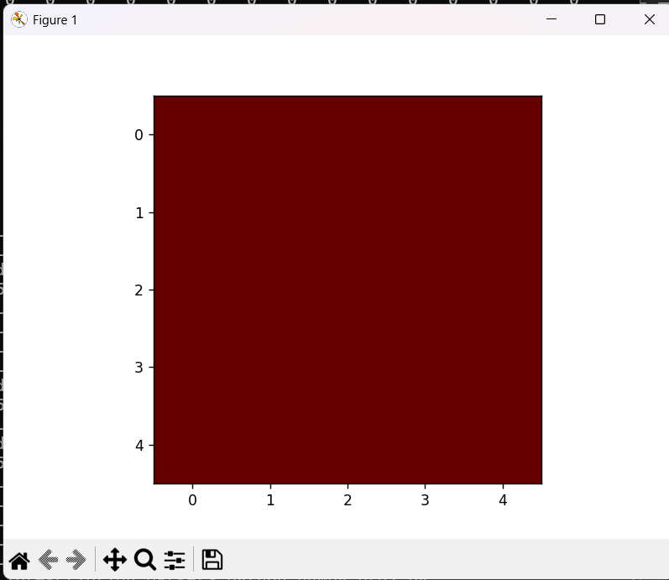

example2:
color = np.zeros((5,5,3), dtype=np.uint8) # tells numpy/matplotlib "these>
color[2,1,1] = 150 # what does this do? guess before running
plt.imshow(color, cmap='gray')
plt.show()
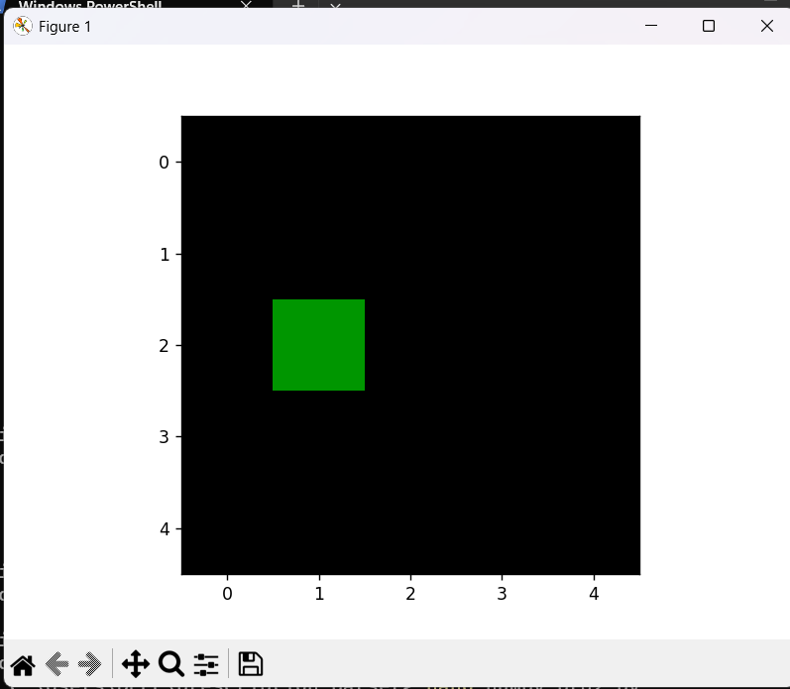
That pixel started as [0, 0, 0] (black, from np.zeros). After this line, it becomes [0, 150, 0] — Red=0, Green=150, Blue=0. Zero red, zero blue, moderate green → that's exactly the green square you see, sitting at row 2, column 1, while every other pixel is untouched and stays [0,0,0] (black).

DAY3:
Workflow Summary
- Sampling with seeds
  - Ran view_samples.py with n=50 and seeds ranging from 100–500.(keep increasing seed range): python view_samples.py --n 50 --seed 600
  - Purpose: explore different random slices of the dataset to capture variety in handwriting and image conditions.
  - Insight: stop once new seeds stop revealing new issues (saturation point).
- Observations logging
  - Documented characteristics in observations.md (contrast, skew, reflection, handwriting style).
  - Used adjectives like flat, even lighting, straight edges (scanned) vs perspective skew, shadows, uneven lighting (phone photo).

DAY4:
- Installed OpenCV and confirmed it's working (4.13.0)
- Wrote preprocess.py with a working load_and_grayscale() function. (Took a sample just to test)
- import cv2 #OpenCV library for img load/process
- import os #std library for interaction w file

- def load_and_grayscale(image_path, output_dir="data/processed"): #processed is the new file name after modification
- # Load the image (OpenCV reads it as a NumPy array in BGR order)
- img = cv2.imread(image_path) #reads file and turns to NumPy array[BGR values] representing pixel values

- if img is None:
- raise FileNotFoundError(f"Could not load image at {image_path}")

- # Convert BGR -> grayscale
- gray = cv2.cvtColor(img, cv2.COLOR_BGR2GRAY)

- # Build an output path based on the input filename
- os.makedirs(output_dir, exist_ok=True)
- filename = os.path.basename(image_path)
- output_path = os.path.join(output_dir, filename)

- # Save the result
- cv2.imwrite(output_path, gray)

- return output_path

- if __name__ == "__main__":
- result_path = load_and_grayscale("data/raw/sample.jpg")
- print(f"Saved grayscale image to: {result_path}")

[Upper code is altered later for project purposes; therefore the original one is attached to understand the concepts used]
- Understood that cv2.imread() loads images as BGR (not RGB) — the classic gotcha(cuz in matplotlib it uses RGB)
- Understood what cv2.cvtColor(..., cv2.COLOR_BGR2GRAY) actually does — collapsing 3 channels into 1 brightness value per pixel[Coolest thing ever!!]
- Ran the script, saved a grayscale output with cv2.imwrite()
- Visually verified the output actually looks black-and-white
- Peeked at the raw pixel arrays to see the shape change from (H, W, 3) → (H, W) firsthand

DAY5:
Goal: Convert grayscale prescription images into pure black/white so text stands out clearly from the background.
What you built
- Added a binarize(img, method) function to preprocess.py, supporting two approaches:
- Otsu's method — automatically picks one global brightness cutoff for the whole image.
- Adaptive thresholding — calculates a local cutoff per region, meant to handle uneven lighting/shadows better.
- Extended preprocess.py with process_sample_images() to loop over images in data/raw/, run both methods, and save results to data/processed/otsu/ and data/processed/adaptive/.
- Created a separate compare_outputs.py script to generate a visual side-by-side grid (original vs. otsu vs. adaptive) using matplotlib, saved as comparison_grid.png.
Otsu — one rule for the whole image
Otsu looks at the entire image's brightness histogram (a count of how many pixels exist at each brightness level, 0-255) and mathematically finds the single cutoff point that best separates it into two groups — "dark stuff" and "light stuff." That one number is then applied to every pixel in the image, no matter where it is.
Assumption baked in: the image has roughly two brightness populations (e.g. dark text vs. light background) and the lighting is consistent enough that one number works everywhere.
Analogy: Imagine grading an exam where you set one pass/fail cutoff (say, 60%) for the entire class, based on how everyone's scores are distributed. Works great if all students took the test under the same conditions.

Adaptive — a different rule for each neighborhood
Adaptive doesn't look at the whole image at once. It slides a small window (in your code, 25×25 pixels) across the image, and for each pixel, it calculates the cutoff using only the brightness values immediately around that pixel — not the whole image.
Assumption baked in: lighting isn't uniform — one corner of the image might be brighter (glare) or darker (shadow) than another, so no single global number would work fairly for both regions.
Analogy: Instead of one pass/fail cutoff for the whole class, you grade each small group of nearby desks using a cutoff based on just that group's scores — accounting for the fact that maybe one row sat near a loud radiator and did worse, unrelated to actual ability.

Bugs hit and fixed along the way
- TypeError: 'Axes' object is not subscriptable — happened when only 1 image was tested, since matplotlib flattens axes differently for a single row. Fixed by wrapping axes in a list when n == 1.
- can't open/read file warnings — caused by running compare_outputs.py before preprocess.py had generated the processed files. Fixed by running scripts in the correct order.
What you observed
- On your evenly-lit prescription text crops (e.g. "Visas", "Telfast", "Azithrocin"), Otsu produced cleaner, smoother text than adaptive.
- Adaptive introduced extra graininess/noise on these samples — likely because there was no lighting gradient for it to actually correct, so its local-window calculation added noise without solving a real problem.
- Flagged as an open question: you haven't yet tested a photo with visible shadow/glare — the scenario adaptive is actually designed for — so the current conclusion is honest but not the full picture.

